Que 1) Plot a histogram,

10, 13, 18, 22, 27, 32, 38, 40, 45, 51, 56, 57, 88, 90, 92, 94, 99

Que 2) In a quant test of the CAT Exam, the population standard deviation is known to be 100. A sample of 25 tests taken has a mean of 520. Construct an 80% CI about the mean.

Que 3) A car believes that the percentage of citizens in city ABC that owns a vehicle is 60% or less. A sales manager disagrees with this. He conducted a hypothesis testing surveying 250 residents & found that 170 residents responded yes to owning a vehicle.

1. State the null & alternate hypothesis.
2. At a 10% significance level, is there enough evidence to support the idea that vehicle owner in ABC city is 60% or less.

Que 4) What is the value of the 99 percentile?

2,2,3,4,5,5,5,6,7,8,8,8,8,8,9,9,10,11,11,12

Que 5) In left & right-skewed data, what is the relationship between mean, median & mode?

Draw the graph to represent the same.

Answer 1:

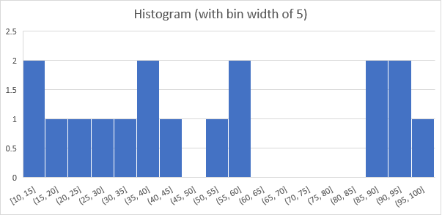

Answer 2: The formula for Confidence Interval (CI) = Mean ± 1.28* S.D./Sqrt.(N)

= 520 ± 1.28(100/Sqrt(25))

= 520 ± 1.28(100/5)

= 520 ± 1.28(20) = 520 ± 25.6 = [525.6, 494.4]

Answer 3:

Null Hypothesis: The share of citizens of city ABC that owns a vehicle is not more than 60%

Alternate Hypothesis: The share of citizens of city ABC that owns a vehicle is greater than 60%

$$Z =\frac{ 0.68 – 0.6}{\sqrt{\frac{0.6(1-0.6)}{250}}}=\frac{0.080}{0.031}≈2.58$$

The statistic is greater than the critical value. So we can reject the null hypothesis.

Answer 4: 11 is the value of the 99th percentile.

Answer 5: In a left skewed data the mean is less than the median, which is less than the mode. See example below. In a right skewed data, the mean has the greatest value, followed by the median and then by the mode. See examples below.

|  |  |
| --- | --- |
|  |  |